[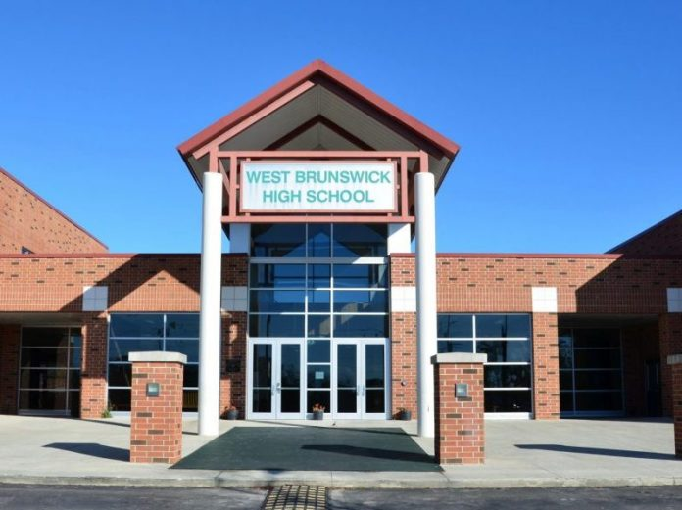](https://www.wwaytv3.com/wp-content/uploads/2017/08/west-brunswick-high-e1487346994913.jpg)

**Type of Project:**

Performance Contract

**Project Location:**

Bolivia, North Carolina

**Project Cost:**

$16,957,562

**Annual Savings:**

$942,087

**Scope of Work:**

T8 to LED Conversion

Exterior & Gym Lighting Retrofit

Building Envelope Weatherization

HVAC Replacement

Energy Management System

Water Conservation Measures

Plug-Load Controls

Solar Picnic Tables

**Role of the Responder:**

Energy Services Company

**Construction Dates:**

August 2017 – Ongoing

**Project Term:**

18 Years

**Project Beginning and End dates:**

2017-2036

**Contact Information:**

Sue Rutledge

Executive Director of Operations

199 Sessions Drive

Bolivia, NC 28422

(910) 253-2900

[srutledge@bcswan.net](mailto:srutledge@bcswan.net)

## Project Description

Brunswick County Schools maintains over 2 million square feet of facilities for their students. Twelve sites still heated their buildings with fuel oil, an expensive and messy energy source. Schneider Electric converted all of these schools to either natural gas or propane, in order to eliminate their use of fuel oil. Converting to natural gas or propane also gave Brunswick County Schools the opportunity to get various new heating system upgrades and refurbishments.

Brunswick County Schools converted their interior and exterior lighting to LED throughout the district. Much of their energy savings came from a comprehensive lighting upgrade. To expand upon lighting savings, four schools received occupancy sensors in areas where data loggers justified the investment financially.

Brunswick County Schools had been dealing with deferred maintenance on hundreds of units across the district for years. Schneider Electric is replacing 26 gas-fired packaged rooftop units across five different schools, to take these units off the district’s deferred maintenance list.

Finally, district administration wanted a way that students could engage with this project. Schneider Electric identified the opportunity to provide solar picnic tables to all three high schools, allowing students to harness solar technology to charge their devices.

Project at a Glance

**Brunswick City Schools**