North Carolina State University
Steam Plant Renovations Project
Cates Central Utility Plant & Yarbrough Drive Steam Plant

Project Title, Location, and Description | 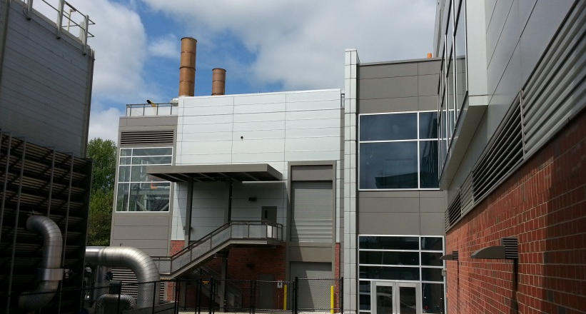  Ameresco implemented a cogeneration and steam plant renovations project at North Carolina State University (NCSU) Cates Plant and Yarbrough Plant, respectively. NCSU’s current steam demand is approximately 200,000 lbs/hr, serving over 6.3 million square feet of space. By 2030, NCSU’s demand is projected to be approximately 320,000 lbs/hr, serving over 8.75 million square feet of space. Existing installed boiler capacity is 300,000 lbs/hr, with a weighted average age in excess of 45 years per boiler. Firm capacity (system capacity with the largest unit of service) is currently 200,000 lbs/hr. Ameresco implemented the following work, which on a combined basis provides total installed capacity of 400,000 lbs/hr (firm capacity of 300,000 lbs/hr) and approximately 11 MW [Nom.] of electricity, roughly 25% to 30% of the current peak campus electrical demand:  Cates Plant – the Cates Plant was configured with two (2) new dual-fuel 5.5 MW [Nom.] combustion turbine generator sets each with a 50,000 lb/hr HRSG and auxiliary dual-fuel duct burners. Additional modifications to the Cates Plant included gutting and demolishing a portion of the plant that housed four chillers and their respective cooling towers, pumps and auxiliary equipment to accommodate the new cogeneration equipment, erecting a new enclosure to house the new cogeneration units, installing a new (Owner procured) 2,000 ton chiller with a (Ameresco Procured) variable frequency drive (VFD) in the 2004 Cates Chiller Plant Addition and one (1) respective (Owner Procured) 6,000 gpm cooling tower, and installing two (2) natural gas compressor packages (one per combustion turbine generator set) to provide the pressure needed to operate the combustion turbines.  Yarbrough Plant – The Yarbrough Plant was configured with two (2) new dual-fuel 100,000 lb/hr boilers and rehabilitating the existing 100,000 lb/hr “Boiler #2”. Additional modifications to the Yarbrough Plant included removing virtually all existing boiler-related equipment, except portions of the recently installed Honeywell control system, providing structural framework to support the new boilers, and installing new working platforms to service the boilers and auxiliary equipment. The Yarbrough Plant chilled water plant was retrofit with one (1) Trane variable frequency drive (VFD).  Existing fuel oil tanks at both the Yarbrough Plant and Cates Plant were cleaned and recertified for low sulfur No. 2 fuel oil (they were using No. 6 fuel oil). No. 6 fuel oil ancillary equipment was removed from both plants.
Installed Project Costs | $65 million
Firm’s Role in Project | Customer provided initial design concept for cogeneration unit and Ameresco worked with their engineer to finalize design; customer reviewed costs for all work bid out by Ameresco and negotiated final project guaranteed maximum price. Customer was also involved in project material selection and pre-purchased certain major equipment. Ameresco was responsible for all budgeting, scheduling, construction management, procurement, site supervision, start-up and commissioning.
Host Reference Contact Name and Phone Number | Ms. Shanna Harwell, CEM, CMVP, PEM, EIT  Interim Director of Energy Management  2411 Yarbrough Drive  Raleigh NC, 27695  (919) 513-0254 Email: smharwel@ncsu.edu
Construction Start and End Dates | Start Date: Dec 2010  End Date: Sep 2012 (Cates) and Aug 2013 (Yarborough)
General Description of Major Equipment Installed | Expansion – Existing Cates CUP  Central Plant Addition  - Two (2) 5.5 MW Solar Taurus 60 Combustion Gas Turbines  - Two (2) 50,000 PPH Dual Fuel Heat Recovery Steam Generators (HRSGs)  - One (1) 2,000 Ton Electric Centrifugal Chiller w/ VFDs  - One (1) 2,000 Ton Cooling Tower  - Repowering – Existing Yarborough CUP  - Demo Existing / New Equipment  - Two (2) 100,000 PPH Dual Fuel Rentec Boilers

